Corvette Club of Hilton Head Island

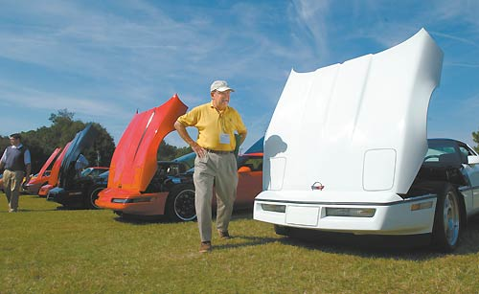

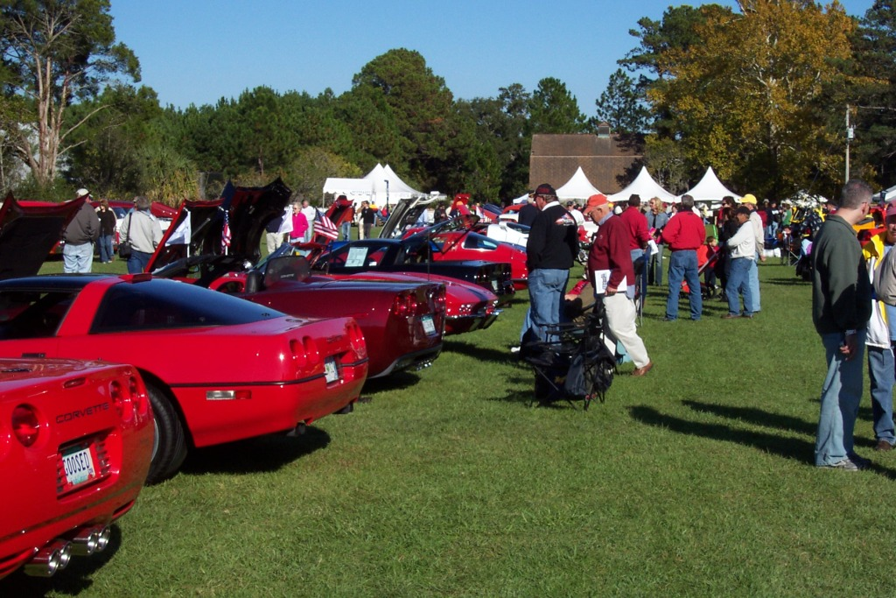

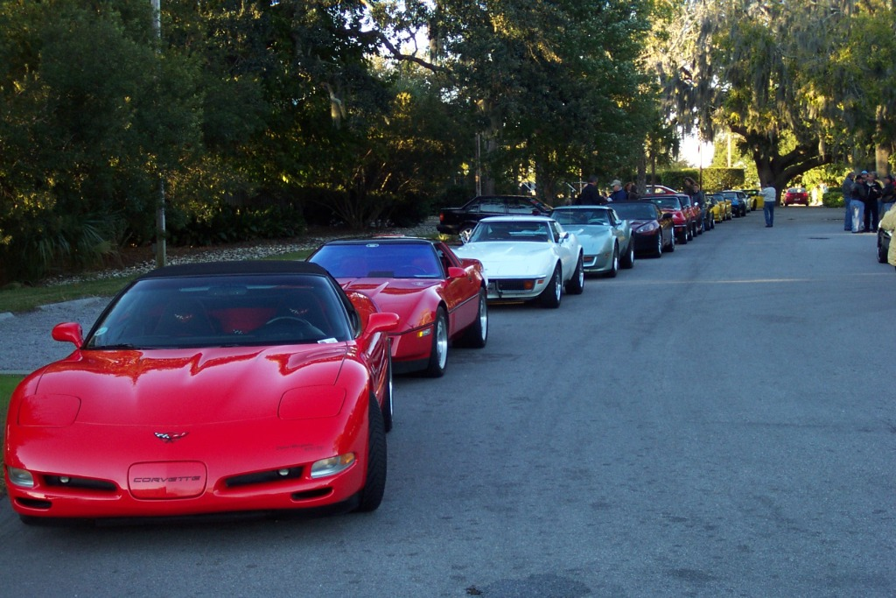

Corvettes of Hilton Head

Attn: Will Meacham

468 Hampton Lake Drive

Bluffton, SC 29910

Hilton Head Island, SC

Phone: 843-342-2862

# Corvette Club of Hilton Head Island

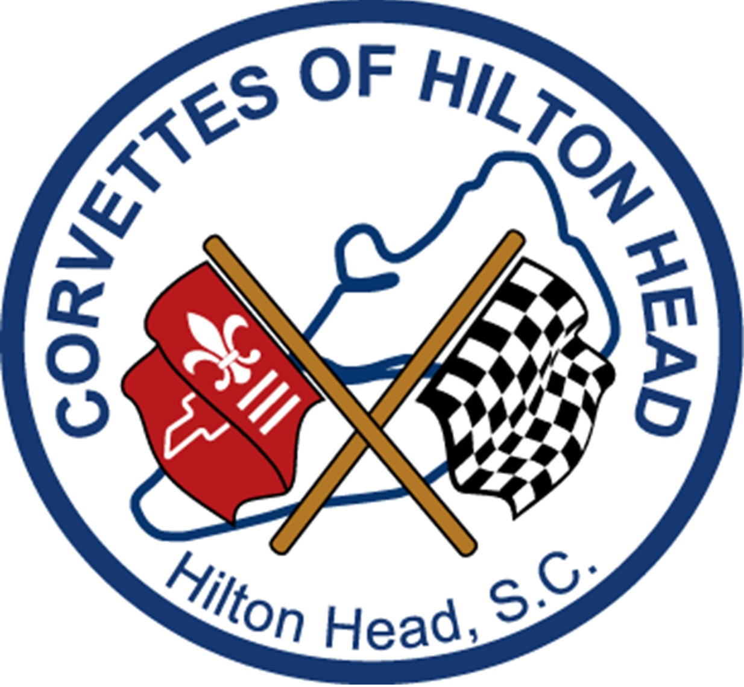

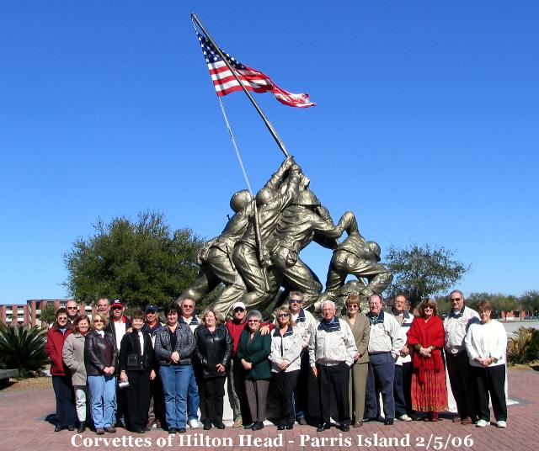

**CCHHI**

“It’s Always a Great Time for a Cruise”

http://www.corvettesofhh.com

Fill out entire form and send it to Corvettes of Hilton Head with a check for $40.00

Mail to: Corvettes of Hilton Head

Attn: Will Meacham

468 Hampton Lake Drive

Bluffton, SC 29910

Date of Application:______  
  
Applicant’s Name: _______________________________  
  
Married:__ Single: ___  
Spouse/ Significant Other’s Name:

_______________­­­­­________________  
  
Address:_____________________  
  
City: ___________________

State: ______Zip:________  
  
Telephone # Home:__________________ Work:__________________  
  
Applicants Birthday:___________________ Spouse/SO Birthday:_____________  
  
Occupation: Applicant_________

Spouse/SO:__________________  
  
**Car Info**:  
Year:____ Coupe:______

Roadster:___ Color:_____  
  
Will you be able to attend meetings? Yes__________ No__________  
  
Will you be able to attend activities? Yes__________ No__________  
  
Email address:_____________________

Club member that recruited you _______

# Our Mission

**Founded in 2004, we are dedicated to promoting the heritage of the Corvette and the friendship of owners and enthusiasts in the Hilton Head and Bluffton area.**

### **About CCHHI**

With more than 70 members, and growing, we are a very active group. We have three scheduled meetings each month and plan at least one other function that takes us on a “cruise” outside Hilton Head.

1st Sat. – Cars & Coffee at Dunkin Donuts – Okatie on 170

2nd Wed. – Business Meeting – 5:30pm location changes each month

3rd Sat – Coffee & Cars at USBC Bluffton -

Among our other events we have Mystery Cruises, joint events with other regional Corvette Clubs and regular dining events throughout the Low Country and Coastal Georgia. We also make regular pilgrimages to Corvette events such as Corvettes @ Carlisle, regional NCRS meets, NASCAR & ALMS races and visits to the National Corvette Museum and Bowling Green. Many of our members actively participate in local car shows. We are members of the Southern Regional Car Council, an organization of car clubs in our area dedicated to promoting the car hobby for all enthusiasts.

Corvettes of Hilton Head is all about the fellowship that owning a Corvette can foster. Whether your Corvette is the fulfillment of a lifelong dream or you are a veteran of owning many, come join us to see what we are all about.

#### Dedicated to America’s Sports Car – The Corvette

If you would like information on becoming a Member of Corvettes of Hilton, please visit our website, come to a Monthly Meeting or contact one of our officers.

[www.corvettesofhh.com](http://www.corvettesofhh.com)

President Joe Wick

917 821-2180